Results/Methods/Discussion/Conclusion of work done with CellModeller from 20-2-18 to 26-2-18

Experiment/Observation 1. a. Staph.Aureus Growth(diameter=0.8micrometer) - 117208 cells in 3.64 hours

Drag=0.943 mg/s, Density(fluid)=1.0039 g/ml[Crystal structure of Staphylococcus aureus exfoliative toxin D-like protein: Structural basis for the high specificity of exfoliative toxins],

Flow velocity(cell)=0.02mm/s, Drag Coefficient=0.47 , Reference Area=10000sq.mm

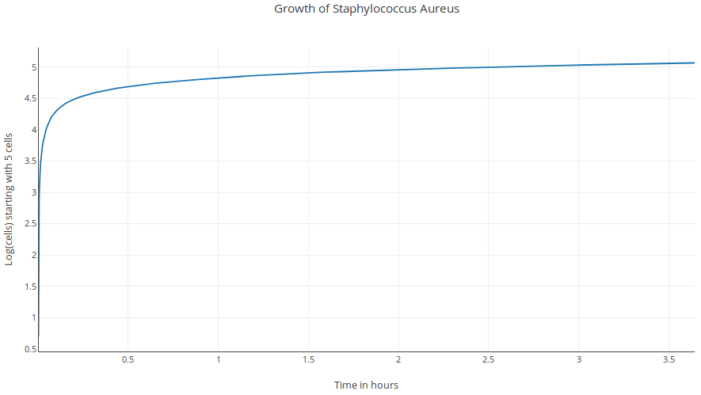

1. b. Staph.Aureus Growth(diameter=0.8micrometer – same as 1.a.) - 995 cells in 23.16 seconds

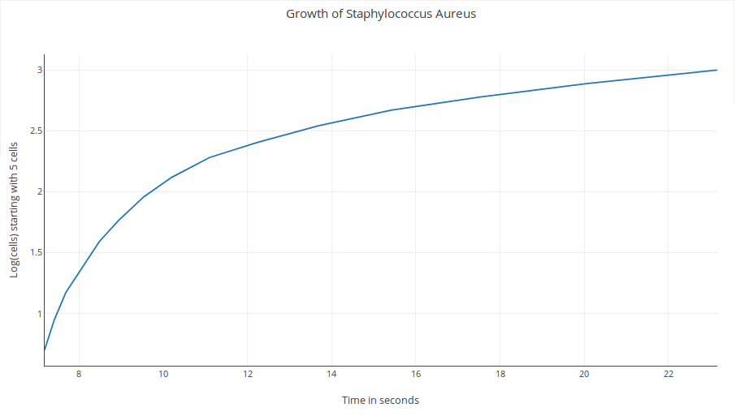

Experiment/Observation 2. a. E.Coli Growth(length=2micrometer) - 119629 cells in 1.70 hours

Drag=2.933 mg/s, Density(fluid)=1.105 g/ml, Flow velocity(cell)=0.03mm/s, Drag Coefficient=0.59 , Reference Area=10000sq.mm

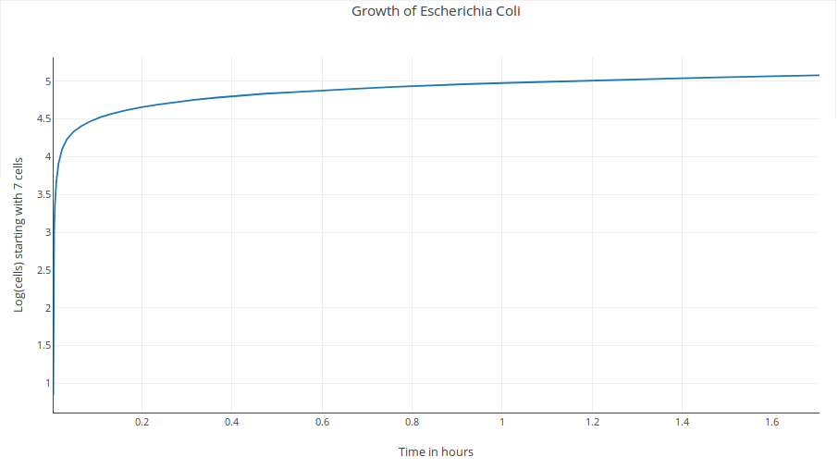2. b. E.Coli Growth(length=2micrometer – same as 2.a.) - 2275 cells in 24.12 seconds

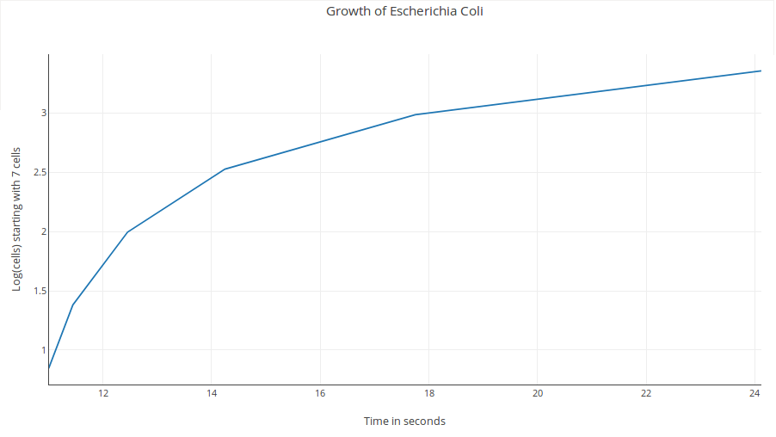

Experiment/Observation 3. a. Staph.Aureus(diameter=0.8micrometer) growth rate speeded up to equal E.Coli's drag – 117158 cells in 2.04 hours and 129981 cells in 2.59 hours

Drag=2.933 mg/s, Density(fluid)=1.0039 g/ml, Flow velocity(cell)=0.03526mm/s(35.26 micrometer/s), Drag Coefficient=0.47 , Reference Area=10000sq.mm

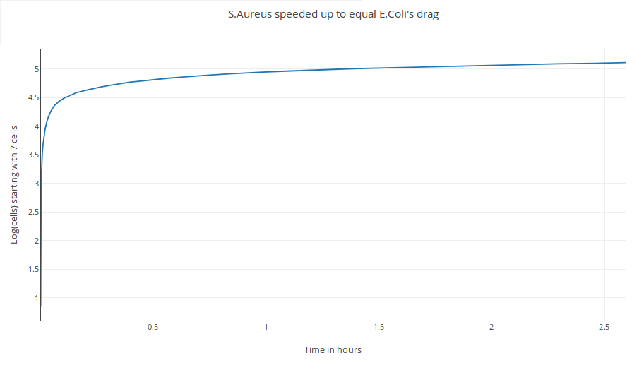

3. b. Staph.Aureus(diameter=0.8micrometer) growth rate speeded up to equal E.Coli's drag

– 2039 cells in 22.42 seconds

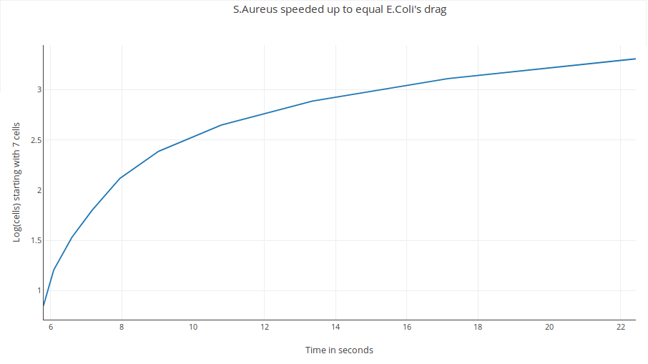

Experiment/Observation 4. Staph Aureus at 1 micrometer compared to Experiment/Observation 1 with all other parameters unchanged

a. 20487 cells in 5.74 minutes at 1micrometer VS 20024 cells in 6.05 minutes at 0.8 micrometer

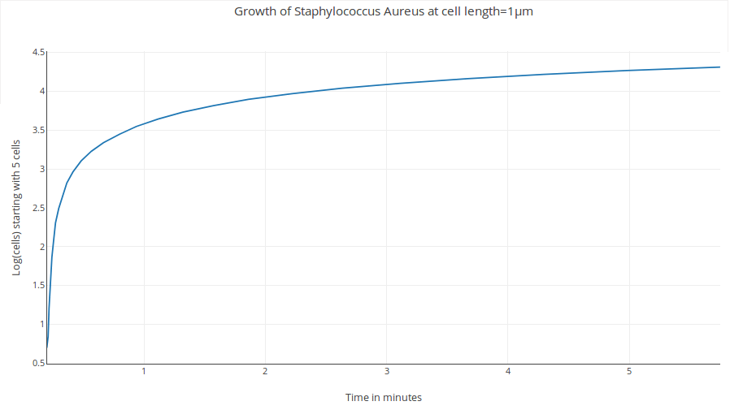

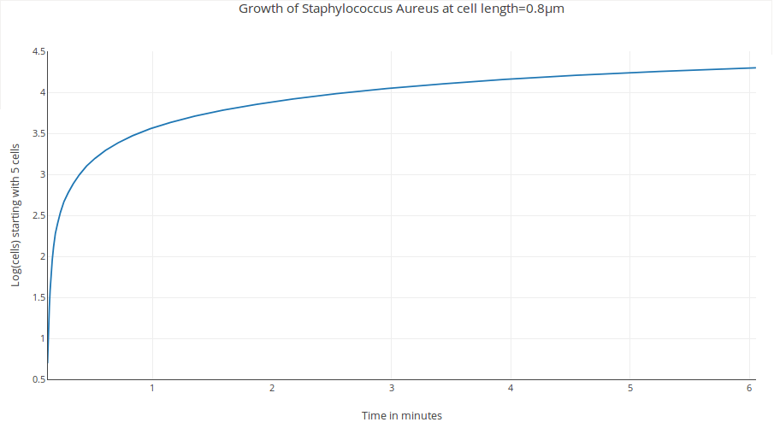

4. b. 4389 cells in 66.96 seconds at 1 micrometer VS 4326 cells in 68.94 seconds at 0.8 micrometer

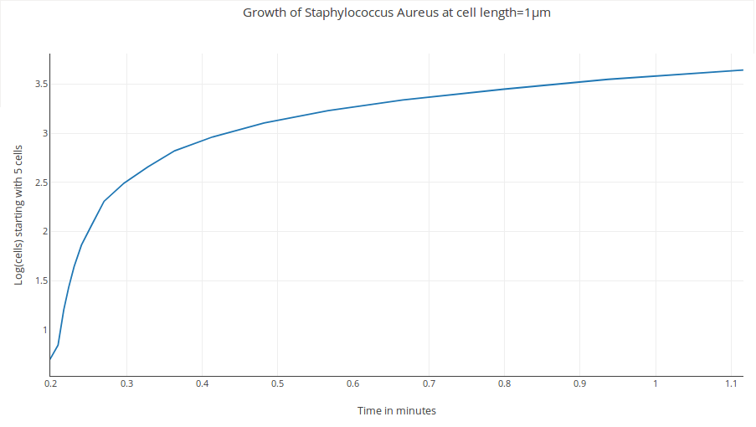

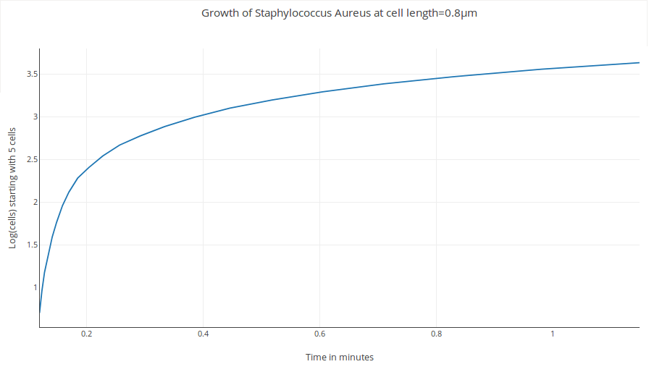

4. c. 116 cells in 15.22 seconds(453 cells in 19.67 seconds) at 1 micrometer VS 467 cells in 15.41 seconds at 0.8 micrometer

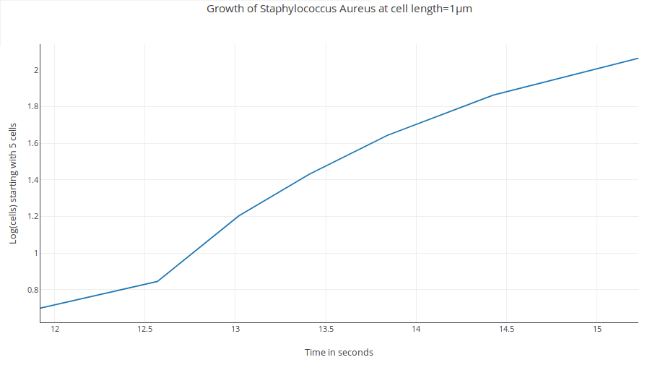

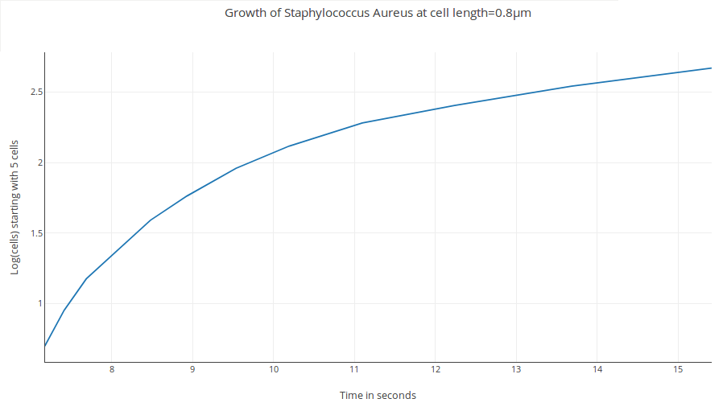

Experiment 5. Staphylococcus Aureus Cell Divisions at minimized growth rate upto 1 minute(other parameters unchanged)

a. 1 micrometer – 16 cells produced in 57.64 seconds

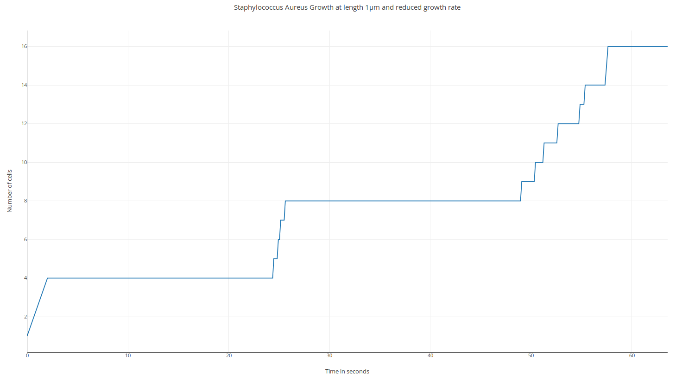

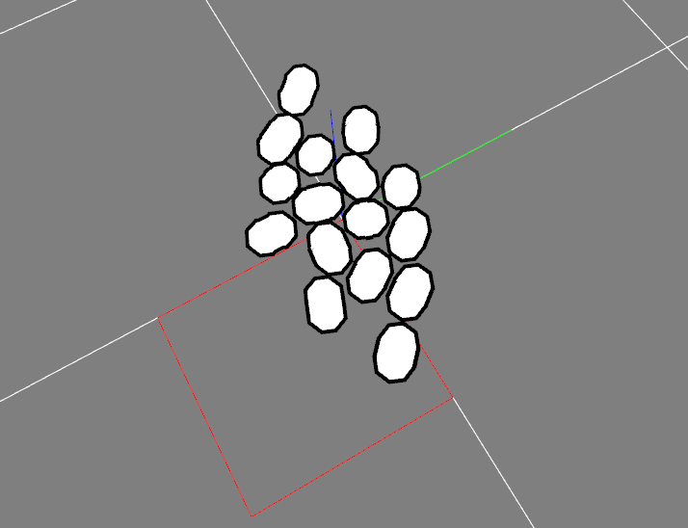

b. 0.8 micrometer – 12 cells produced in 60.17 seconds

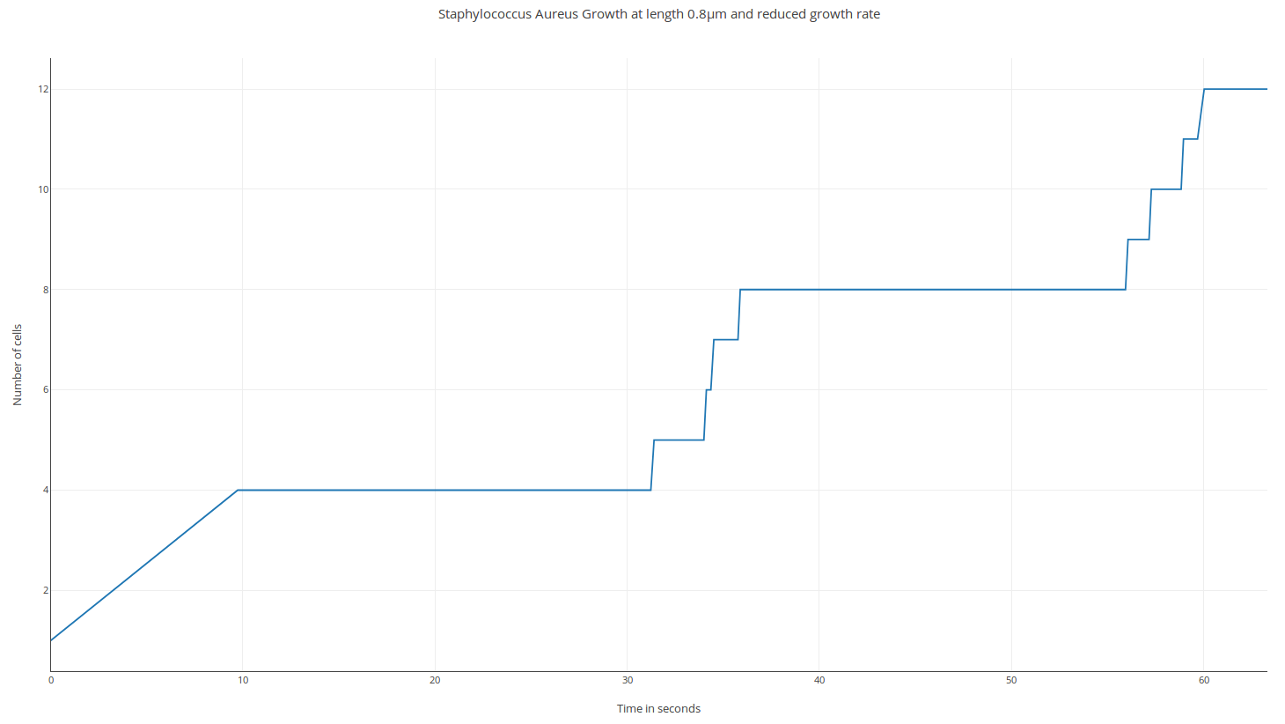

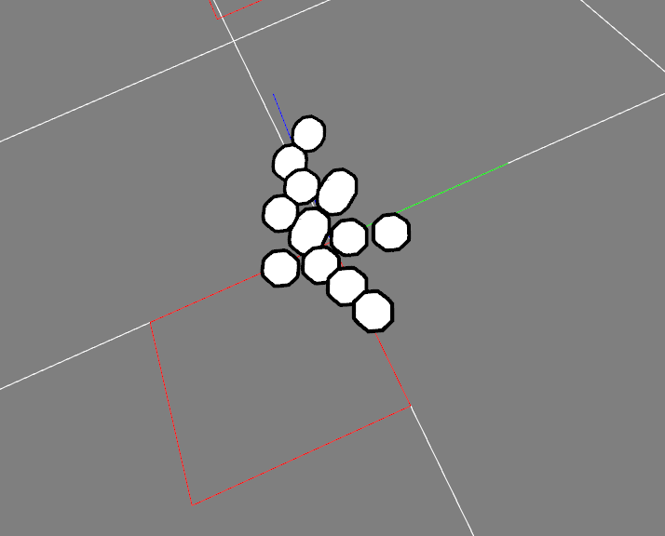

Discussion:

The first experiment was performed to observe the growth pattern of Staphylococcus Aureus with the following input parameters:

Drag=0.943 mg/s, Density(fluid)=1.0039 g/ml, Flow velocity(cell)=0.02mm/s, Drag Coefficient=0.47 , Reference Area=10000sq.mm, Cell diameter=0.8 micrometer

It took 3.64 hours to produce 117208 cells. The exponential curve can be observed in figure 1.b.

The second experiment was performed to observe the growth pattern of Escherichia Coli with the following input parameters:

Drag=2.933 mg/s, Density(fluid)=1.105 g/ml, Flow velocity(cell)=0.03mm/s, Drag Coefficient=0.59 , Reference Area=10000sq.mm, Cell length=2 micrometer

It took 1.70 hours to produce 119629 cells. The growth curves can be observed in figure 2. a & b.

The next experiment was an attempt to help Staphylococcus Aureus match upto Escherichia Coli's growth pattern. The flow velocity was increased to 35.26 micrometer/s from 20 micrometer/s[Figure 3.a. and b.]

Experiment 4 is an observation of S.Aureus with two cell diameters(1 and 0.8 micrometer) at different time scales[Figures 4.a-c]

The last and final experiment was carried out to observe S.Aureus cell division w.r.t a time frame of 1 minute[Figure 5.a. and b.]. Growth rate was reduced by 24 times.

Methods:

Approximate number of cells in a circular microcolony consisting of spherical cells:

Let D be the diameter of the microcolony and d be the diameter of a single spherical cell in the microcolony.

Surface area of entire microcolony = πR2 = π(D/2)2 = (πD2)/4

Surface area occupied by a single spherical cell = (4πr2)/2 = 2πr2 = (πd2)/2

Hence the approximate number of cells in that microcolony would never be lesser than (D2/d2)/2

Based on the above approximation,

a. the number of cells in a 65 micrometer diameter microcolony would be around 825 or more

b. the number of cells in a 78 micrometer diameter microcolony would be around 1188 or more

c. the number of cells in a 156 micrometer diameter microcolony would be around 4753 or more

[Reference: Viscoelasticity of Staphylococcus aureus Biofilms in Response to Fluid Shear Allows Resistance to Detachment and Facilitates Rolling Migration]

Duplication time of Escherichia Coli(E.Coli) = 20 minutes[]

Duplication time of Staphylococcus Aureus(S.Aureus) = 27 minutes[]

Hence S.Aureus is ~1.35 times slower than E.Coli

Flow velocity of E.Coli = 30 micrometer/s = 0.03 mm/s

Approximately, flow velocity of S.Aureus = 30/1.35 micrometer/s = 22.22 micrometer/s ≃ 0.02 mm/s[also based on reference paper on dynamic flow spectroscopy which mentions a velocity value of S.Aureus = 20 micrometer/s]

It was calculated that E.Coli's drag is more than 3 times S.Aureus's drag and that the flow velocity of Staph. Aureus should be 35.26 micrometer/s i.e 0.03526 mm/s(greater than E.Coli's) so that the drag would be 2.933 mg/s(identical to E.Coli).

Conclusion

To equate the drag of Staphylococcus Aureus to that of Escherichia Coli's, the flow velocity had to be increased from 20 micrometer/s to 35.26 micrometer/s which is even higher than that of E.Coli's own flow velocity(30 micrometer/s). Inspite of the same, E.Coli cell count was still found to be comparatively higher than that of S.Aureus at similar time intervals.

It was observed in 4.a. and 4.b that the cell count was lesser in case of 0.8 micrometer diameter of S.Aureus when compared to 1 micrometer. In 4.c., a ~5 second delay was observed in 1 micrometer S. Aureus to be able to produce a similar cell count as for 0.8 micrometer(453 cells in 19.67 seconds). At 1 micrometer diameter of Staphylococcus Aureus, 116 cells were produced in 15.22 seconds whereas 467 cells were produced in 15.41 seconds at 0.8 micrometer. There is a noticeable difference between the growth curves for experiment/observation 4.c. This could imply that the ideal diameter of a staph.aureus cell to have a proper exponential growth curve should be 0.8 micrometer. To reobserve this, experiment 5 was performed. The growth rate was reduced by 24 times and the corresponding graphs were plotted for cell count w.r.t a minute time scale. It was observed that at that heavily minimized growth rate, where cell count was reported every second(based on an update that was made in the progress_finalize() function in the Biophysics module of CellModeller), 16 cells were produced in 57.64 seconds at 1 micrometer diameter and 12 cells were produced in 60.17 seconds at 0.8 diameter of Staphylococcus Aureus.

The 3 cell counts obtained in the case of the 3 given microcolony diameters[] were observed to grow while not reaching any of the four boundaries of the assumed cuboidal structure, confirming growth upto that period on the base plane.

Since flow velocity plays an important role in the dynamic behaviour of biofilms[Impact of flow velocity on the dynamic behaviour of biofilm bacteria] and Stokes law does not hold at high velocities[], we can use higher flow velocity values(can be used as input parameters) to better understand biofilm behaviour. This is because higher velocities would result in higher drag values according to the drag equation[previous E.coli experiment. December 2016].